**Computer Organization and Architecture**

**Architecture** : Abstract/logics

Eg:2*6, After giving this input, what the keyboard, memory , processor, ALU , control unit will do??

Note: How the process is done not necessary What are all the process’s to do that matters

**Organization** : Organizing the plan.

Eg: Builder sees a plan and he is the person who implements the plan into a house, he knows how to construct a building from scratch.

**Architecture** **Organization**

How the process is done??? What are all the process to do??

**Von Newmann Architecture:**

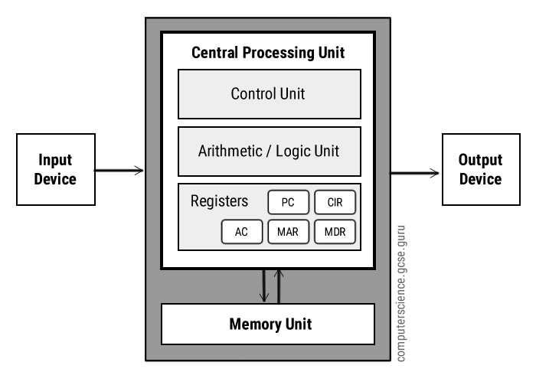

**Data + programs**

**Registers :** Smallest size, temporary memory. Sequence of bits like 8 bit , 16 bit.

What is the purpose of registers in-spite there is Main memory ?? Why the registers are on the top of CPU???

Speed of main-memory<ALU (In-order to match the speed difference Registers will come into picture) It stores the temporary, intermediate results. It will serve as an intermediate between ALU and main memory.

**Control Unit:**

Timing Signals: eg, there are 10 instructions waiting for the execution. Among that 10 which one is important, preference, required. So the instructions are shuffled based on the requirements and will be executed.

Control signals : It specifies what are all the operations should be done on the registers. Takes the complete control of registers.

**Registers**

Memory (4096 * 16)

Word : Memory representation unit



4096 🡪 Number of words (How many words are we storing in RAM)



16 🡪 Word size (How many bits can be stored in a single word )

In our eg: 1 word = 2 bytes(1 byte=8 bit)

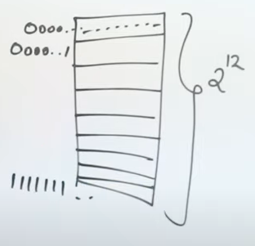



First line 12 zeros

Total 2^12 🡪 4096, So in this memory 4096 words can be stored. Each word contains only 2 bytes(16 bit)

Last line 12 ones

Address register The total size of the address register is 12 bits



Data register The total size of the data register is 16 bits





1st row contains 2 words (i.e 16 bits)



**Accumulator**  : Stores the intermediate data  
 Memory data Accumulator data ALU



Accumulator It stores the data, so the size of data register is



same as that of the Accumulator (16 bits)

**Program Counter** : Holds the address of next instruction to be executed. Since it holds only the address, the total size of address register is same as the program counter.



Program Counter The total size of the Program counter is 12 bits



**Instruction Register(IR) / Current Instruction Register(CIR)** :

Direct Addressing(0)

1 Add 450

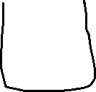

Value



Indirect Addressing (1)  
 1 Add 450

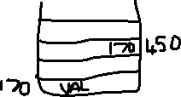

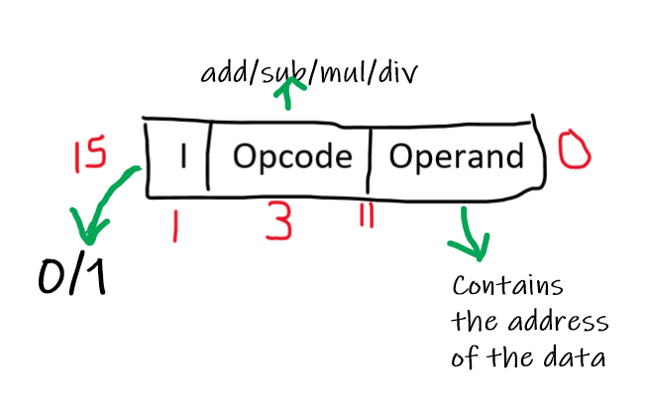

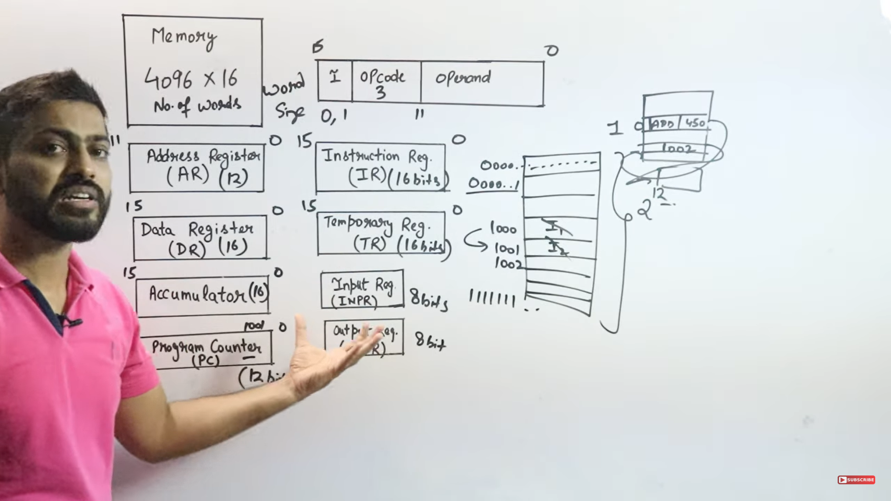

**Types of Buses(Address,Data,Control)**

**Address Bus (Unidirectional)**It carries the address of data from CPU to Memory, input, output.  
The length of the address bus is 16 bits ( 2^16)   
The address bus have 2^16 slots to hold the data.   
For eg: If I have 3 bits, 2^3🡪8 slots to hold the data.

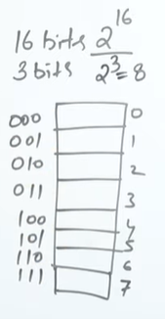

In 3 bit processor there are 8 slots to store the data.

In 16-bit processor there are 2^16 🡪 65536 slots are there to store the data.



**Data Bus (Bidirectional) :**It carries the data from CPU to Memory, input, output.   
It caries data from Memory, input to CPU.  
The length of data bus is 16 bit.  
 



Each and every slots contains a word which is 2 bytes. So the data bus fetches the data from the memory which is 2 bytes. Suppose if the user gives 1 byte (it will accept)

000000 Input value



**Control Bus (Unidirectional)**It sends the control signals to Memory, input, output.It assigns the control signal and timing signal.  
It will send the control signal to the memory when to read, write the data from memory.  
It will send the control signal to the input , to take the input from the user.

It sends the timing signal in the form of clock pulse.

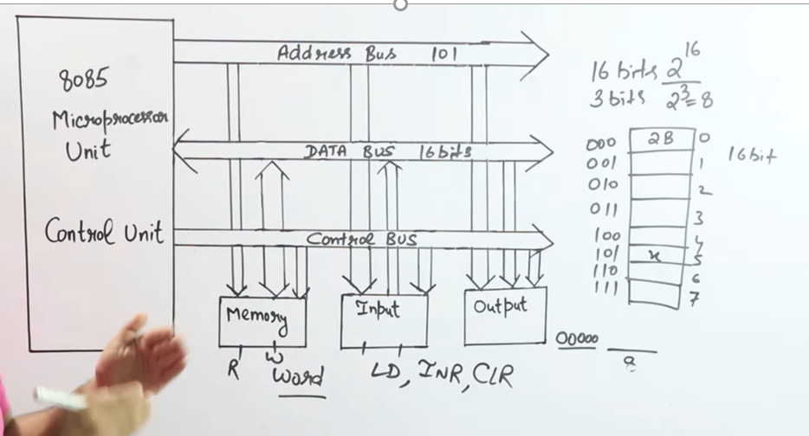

Types of Instruction in General purpose Computer

Data Transfer Instructions : Contains the instructions which is used to transfer the data between registers, memory, I/O devices

Data Manipulation Instructions : Contains the instructions which is used to change/modify the data.

Program Control Instructions : Contains the instruction which is used to execute loops, if-else statements.

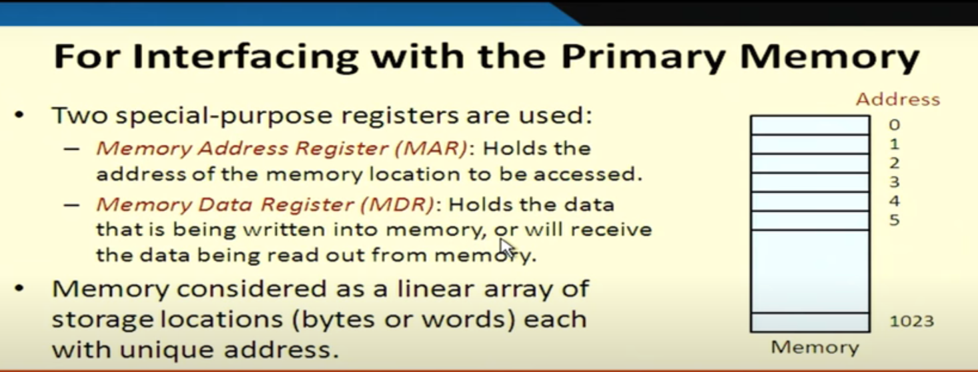

Memory Data-Registers : When we write, we write the data into the memory. But when we read the data we can read **1) Data (or)   
2) Instruction.  
Memory data register 🡪 Data write (or) Data read (or) Instruction**

Memory Address Registers

Eg: MAR holds 5, then MDR holds the content stored in 5

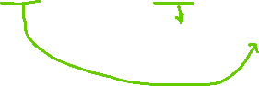

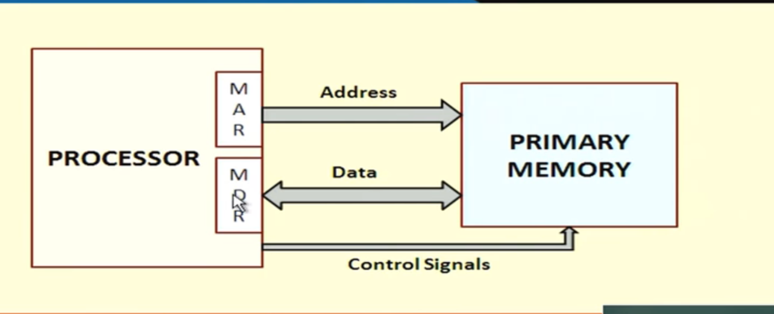

Read ( I want to read a particular value from a particular address )  
Processor will give the address ( which hurts the main memory). Now control signal is **read**  so that address is back to the processor to read that particular value.

Control signal 🡪 Read/Write operation

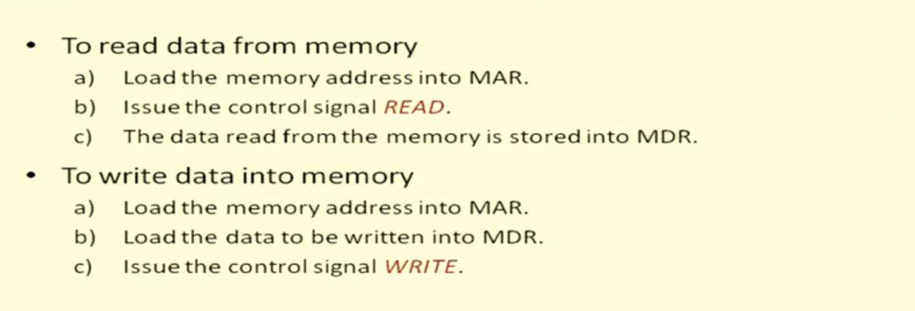

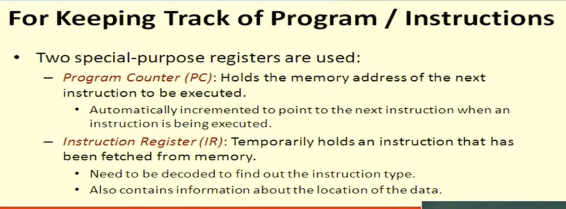

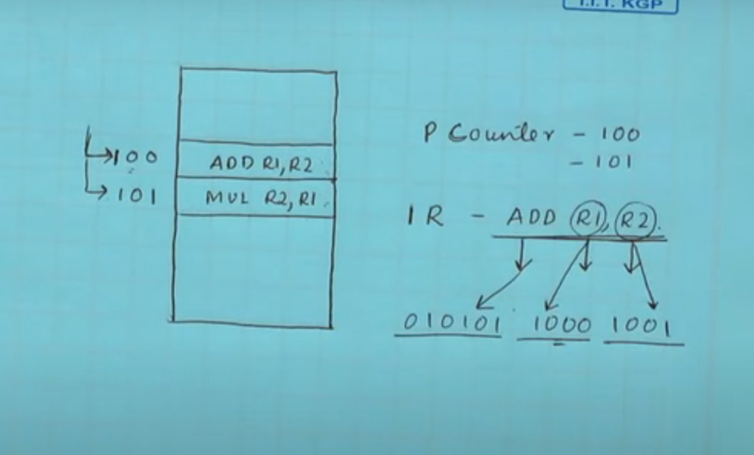



PC holds the address of the instruction register.   
IR holds opcode and data



Decoded information , R1 and R2 holds the data.



How to the processor is connected with the registers????

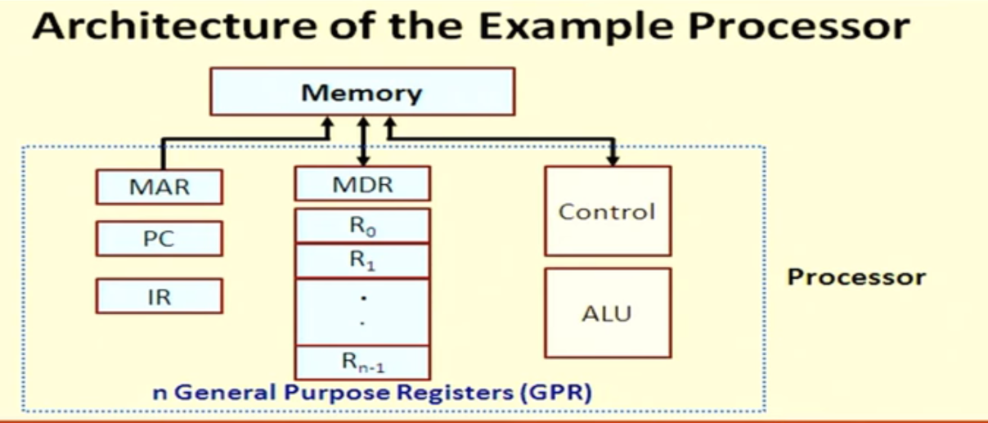

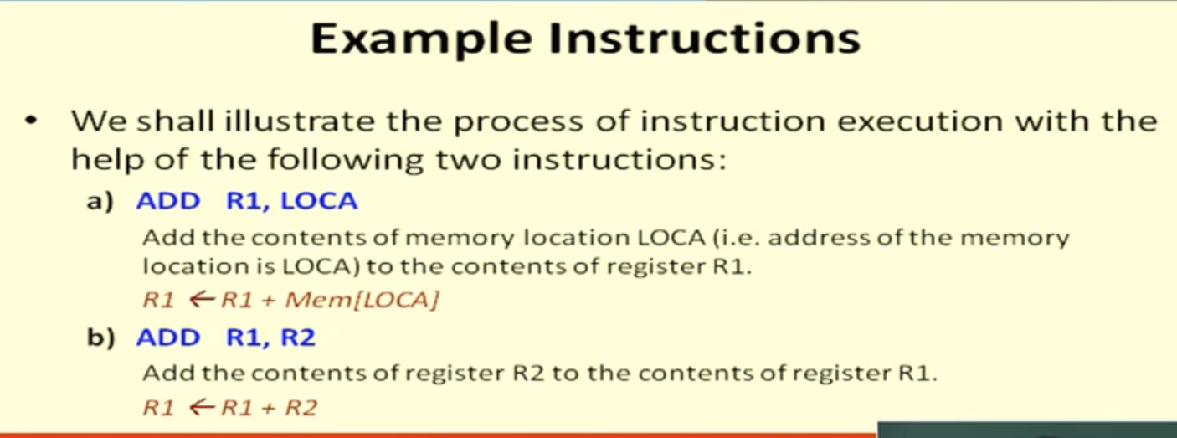

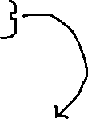

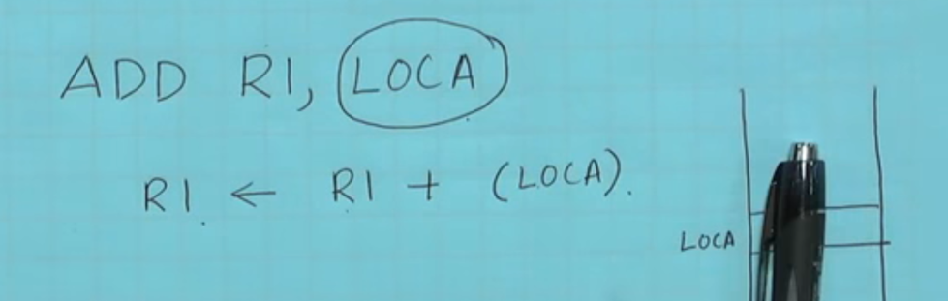



LOCA 🡪 Value stored in location A. It will be added with R1 register and stored back to R1

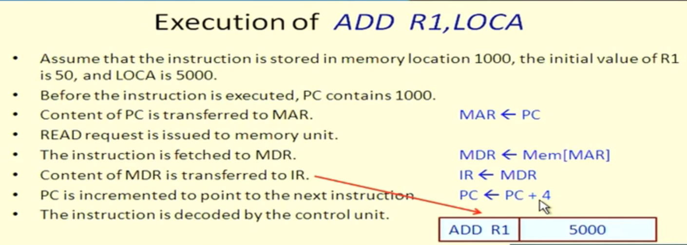

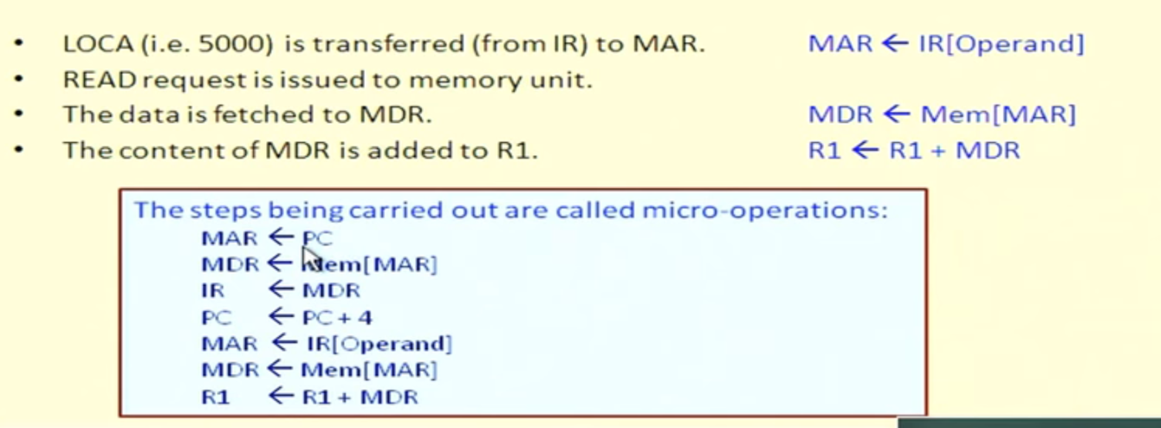

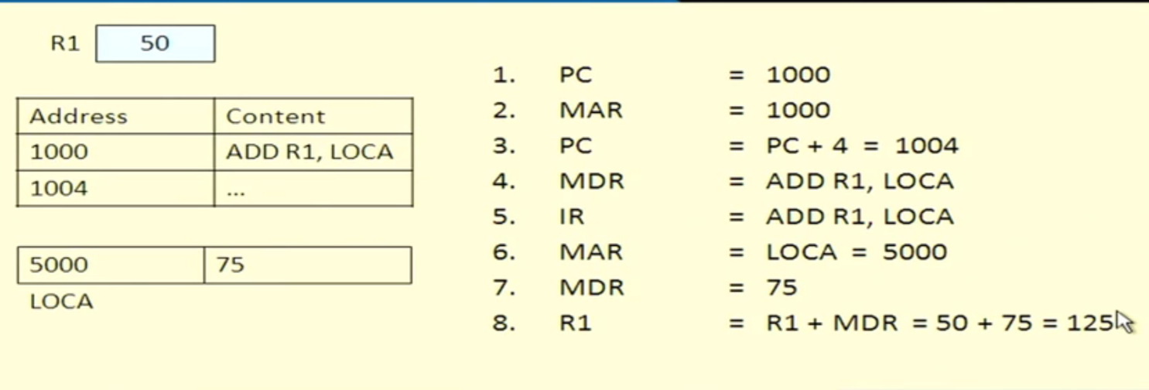

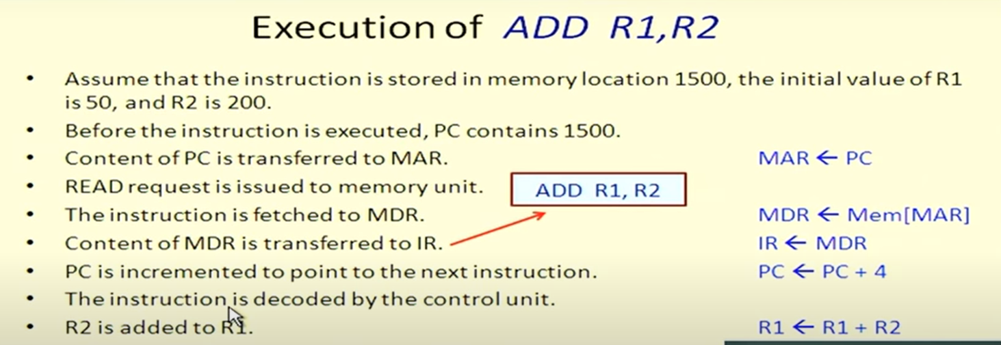

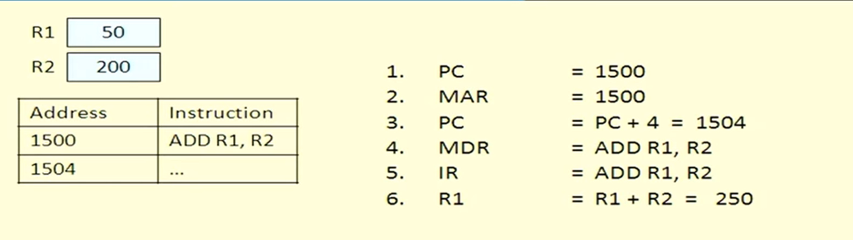



For an instance when the memory is communicating with the BUS, only that activity takes place rest of them cannot able to communicate at that instance.

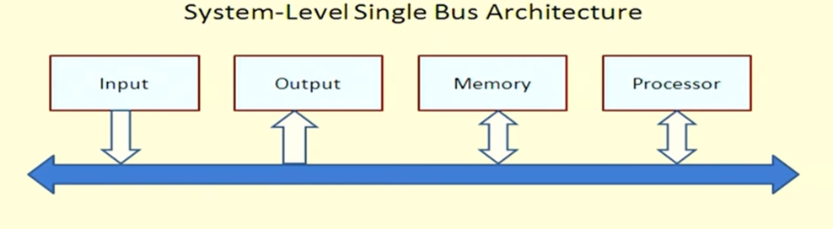

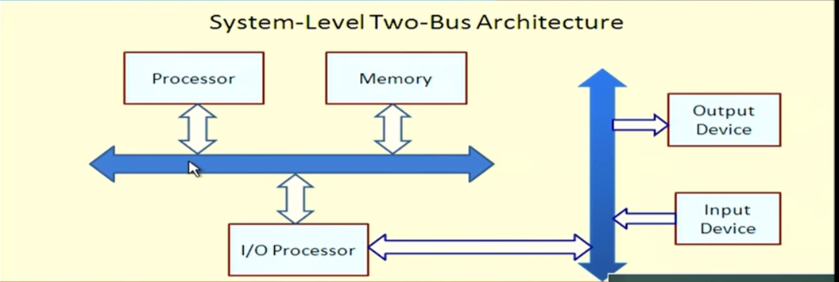



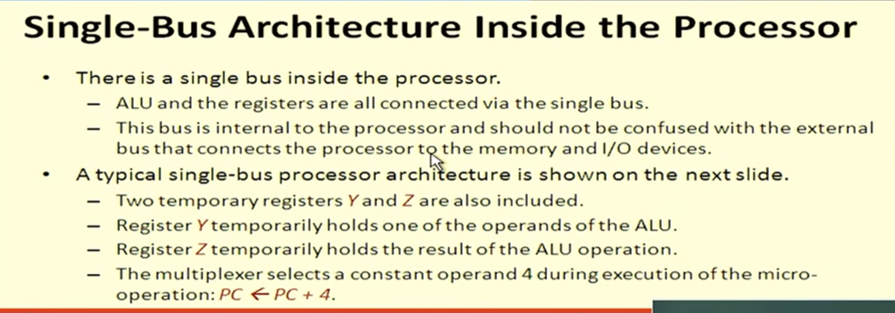

Over here each and every control is carried via bus

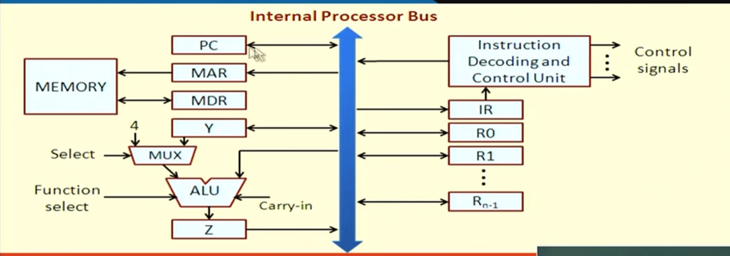

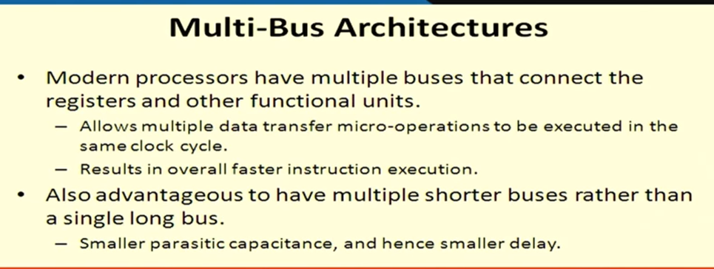

Lecture-3 Memory Addressing and Language

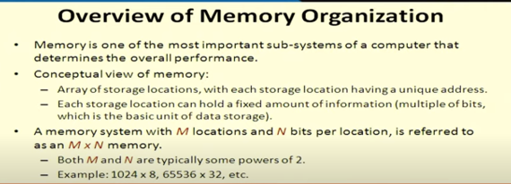

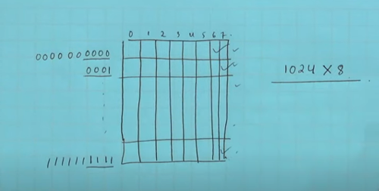



1st row (10 zeros) with 8 columns

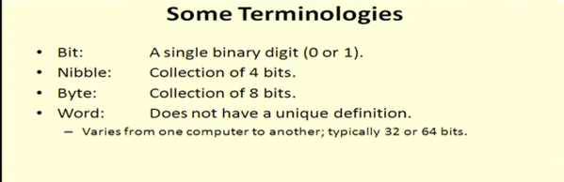

Word depends upon the bit of the computer

Memory is completely byte organized ( NOT BIT organised)

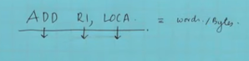

How many words/bytes this instruction will have ???

This depends on various factors like number of instructions, the total number of registers available, total number of location variable present.



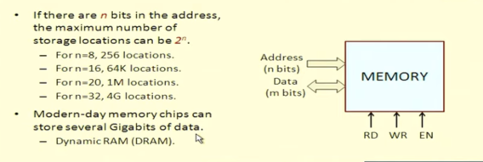



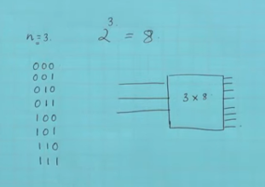



Here it is 3 bits in the address so 2^3 = 8 (maximum number of storage locations) [These are the addresses of the storage location]

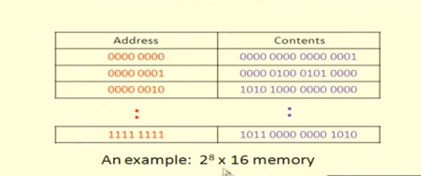

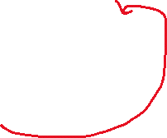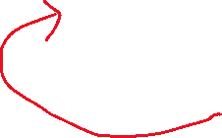

Here 1st row 🡪 8 bits   
Like this 2^8 rows will be there.

In a single row’s contents 🡪 16 bits

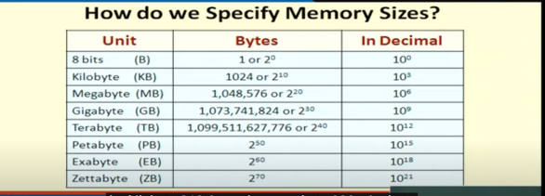

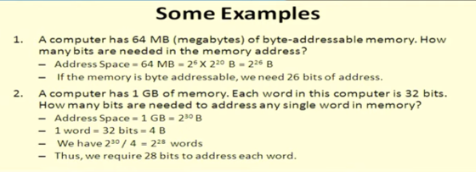

In a 32-bit PC, 1 word 🡪 4 bytes

2^30 bytes



Total Number of words 🡪 2^30/4 🡪 2^28 words

Each word is 32-bit, and each word requires 28 bits for addressing

Normal 1 GB representation With 4 byte word

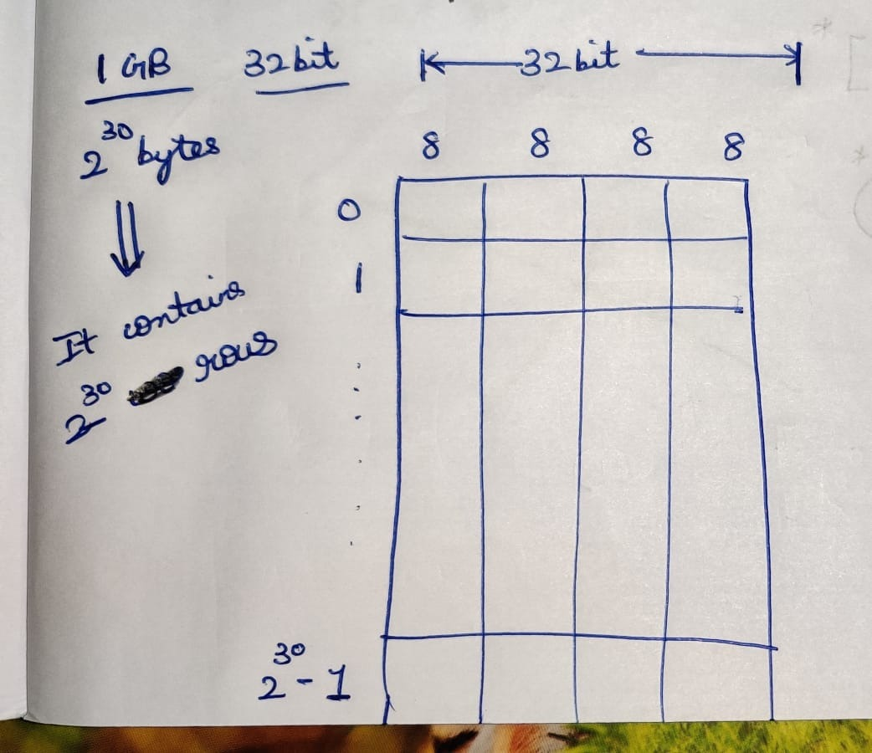 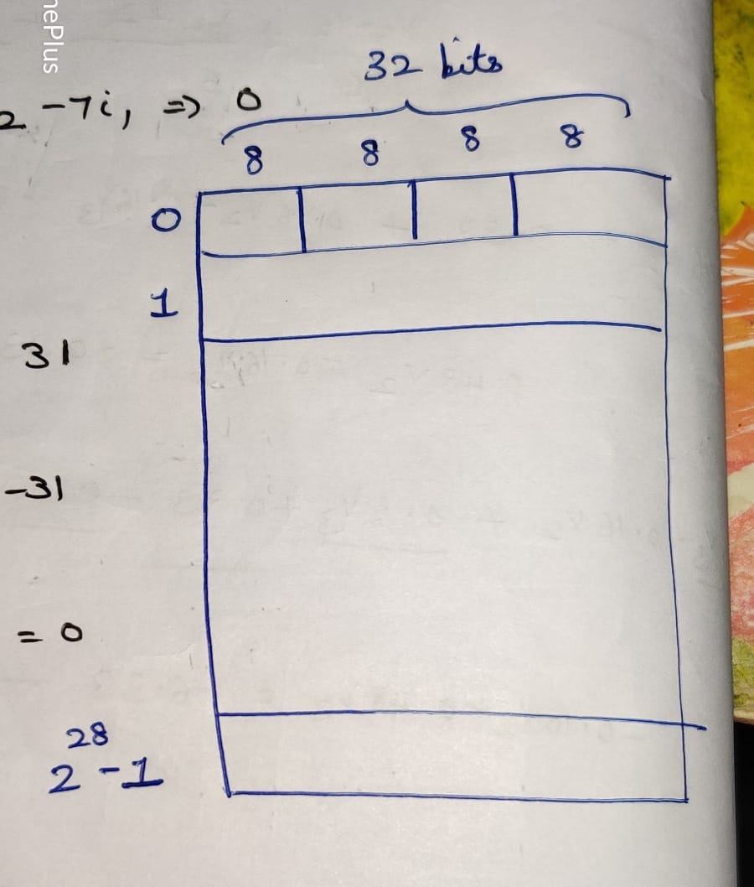

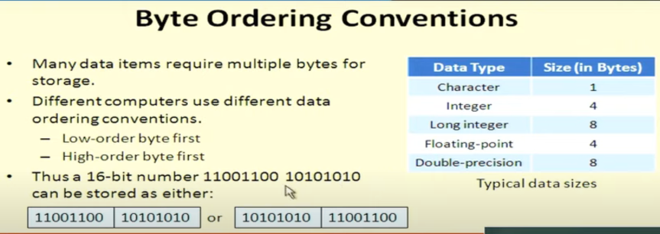

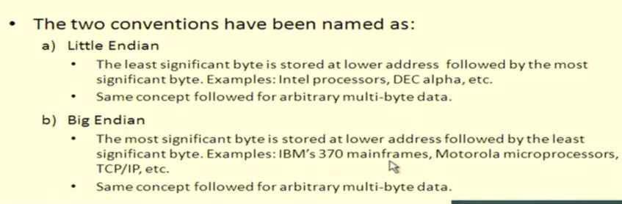

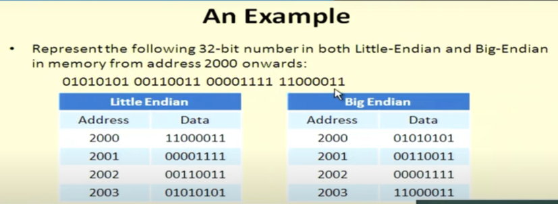



From LSB to MSB From MSB to LSB

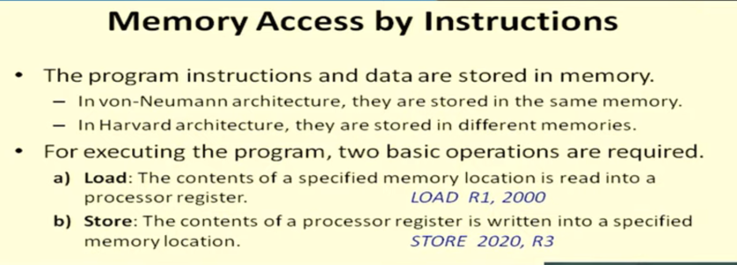

Load 🡪 Load from memory into the processor register  
LOAD R1,2000 ( Load the register R1 from address 2000)

Store 🡪 Store into memory from the processor register  
STORE 2020,R3 ( Storing the contents of R3 into the address 2020)

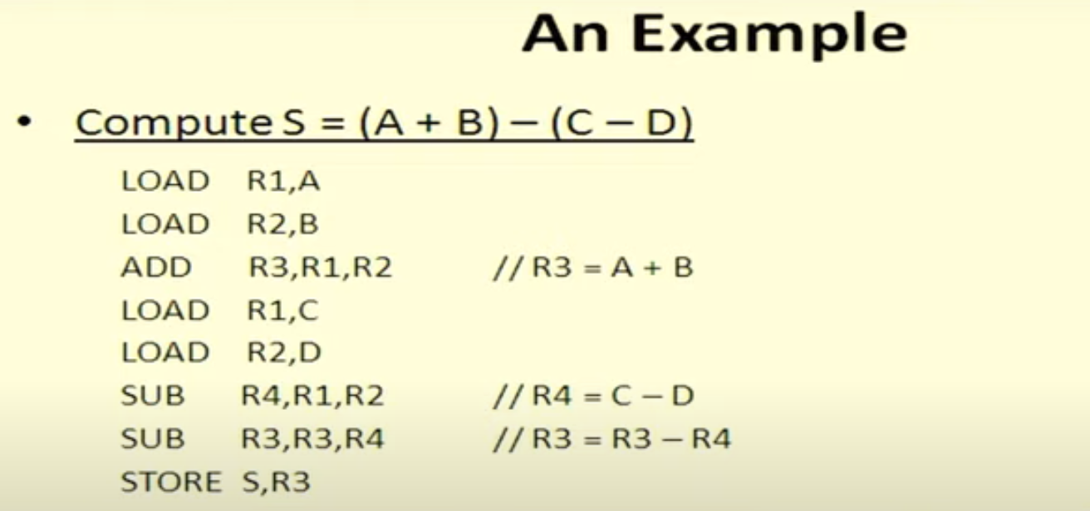

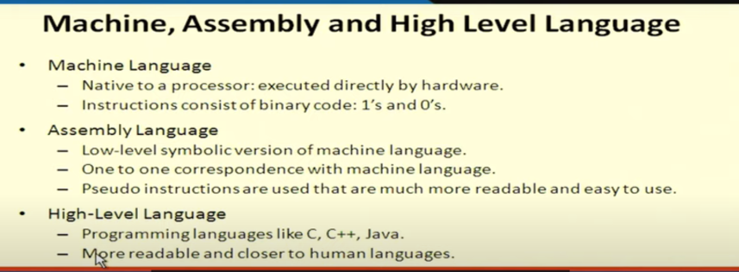

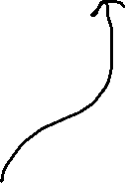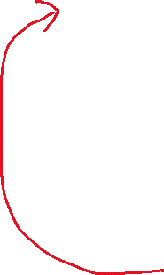

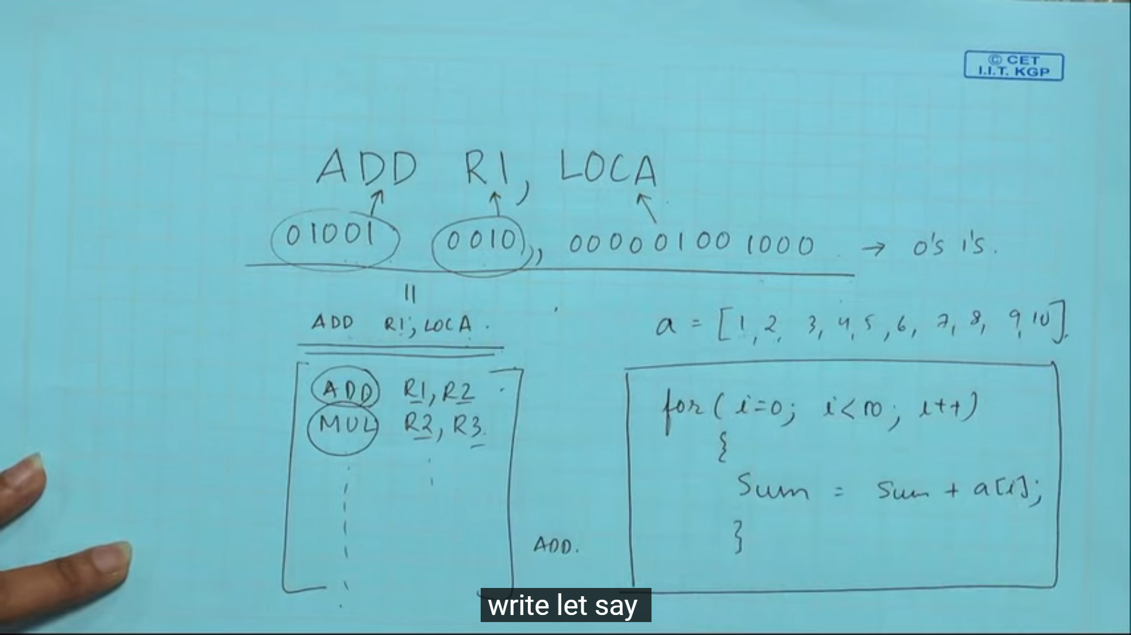

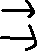

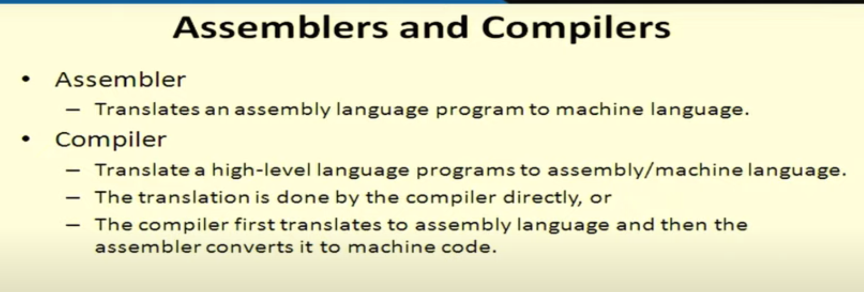

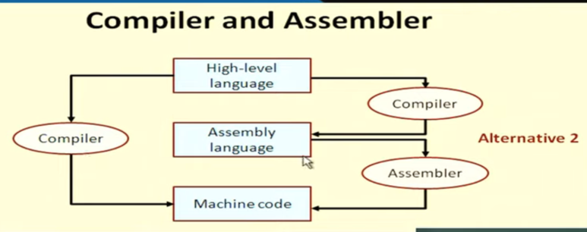

Writing code in 1 machine but compiled in another machine

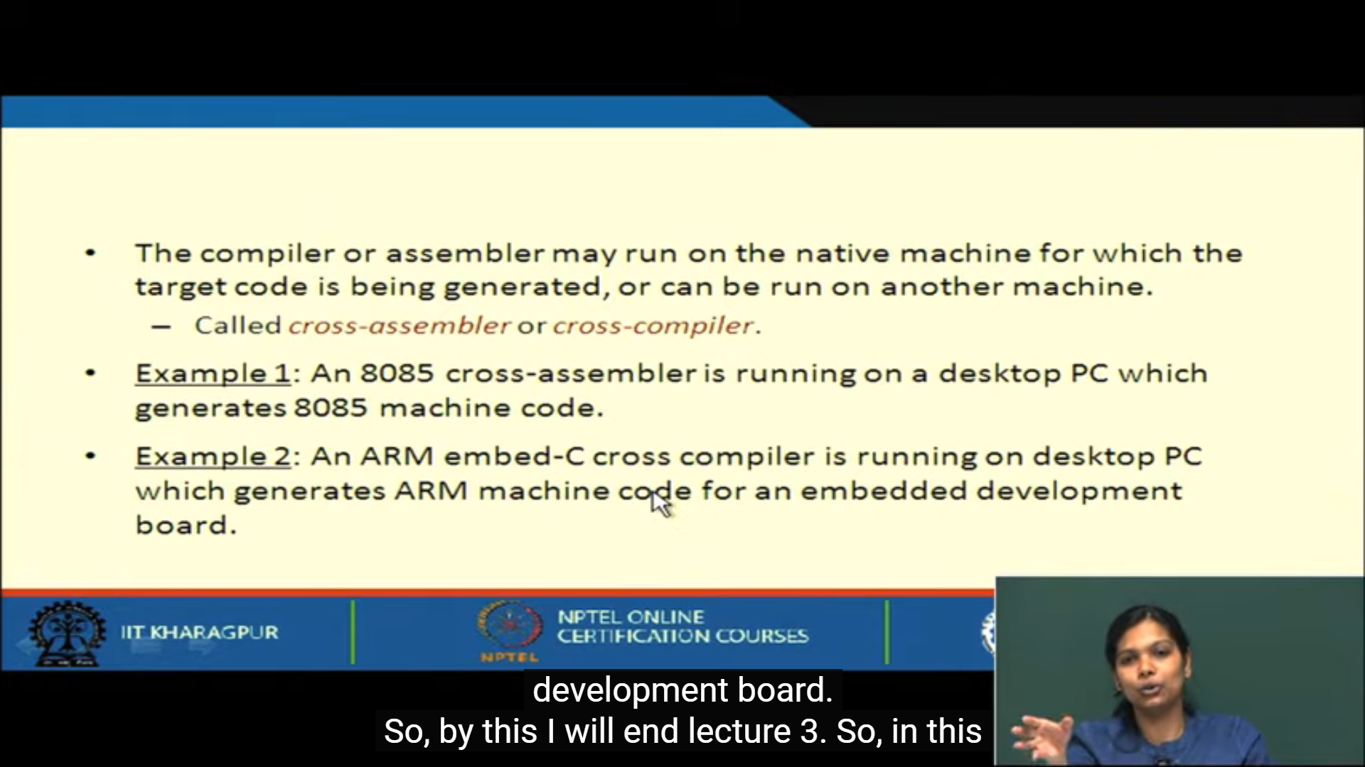

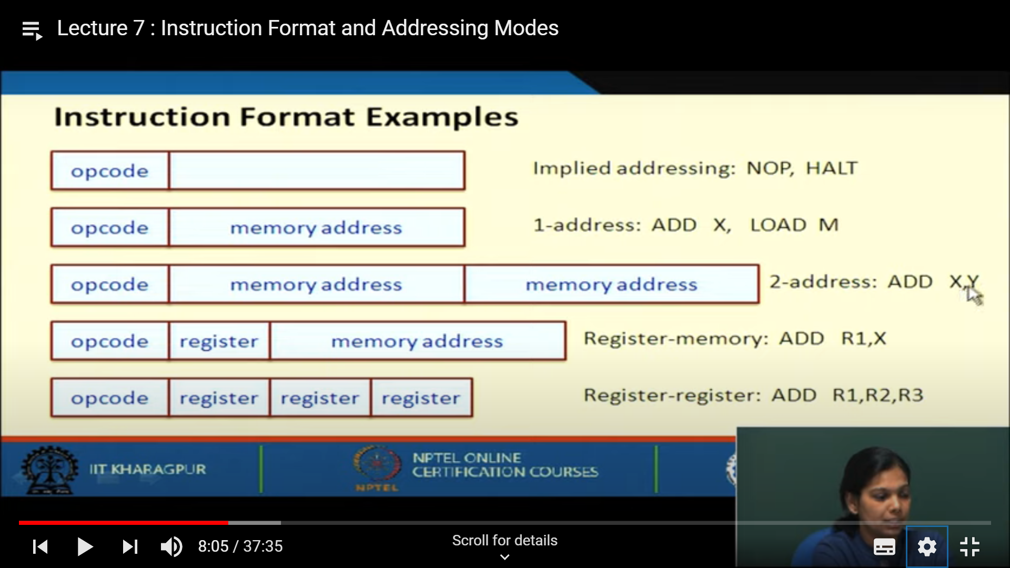

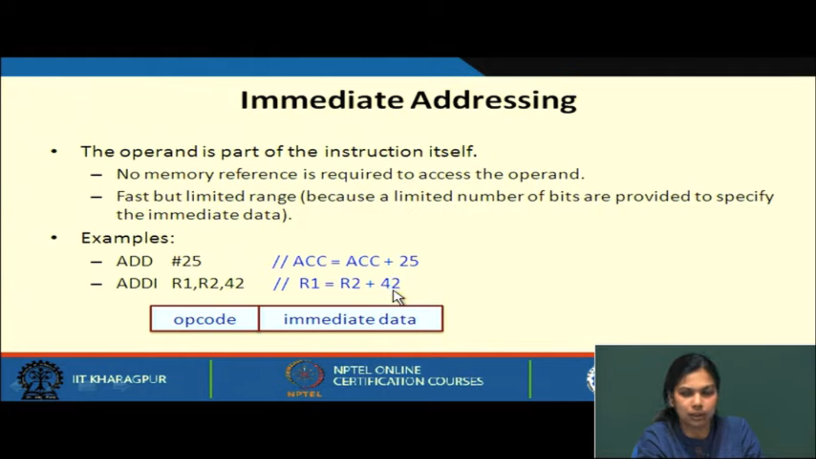

1 time memory access

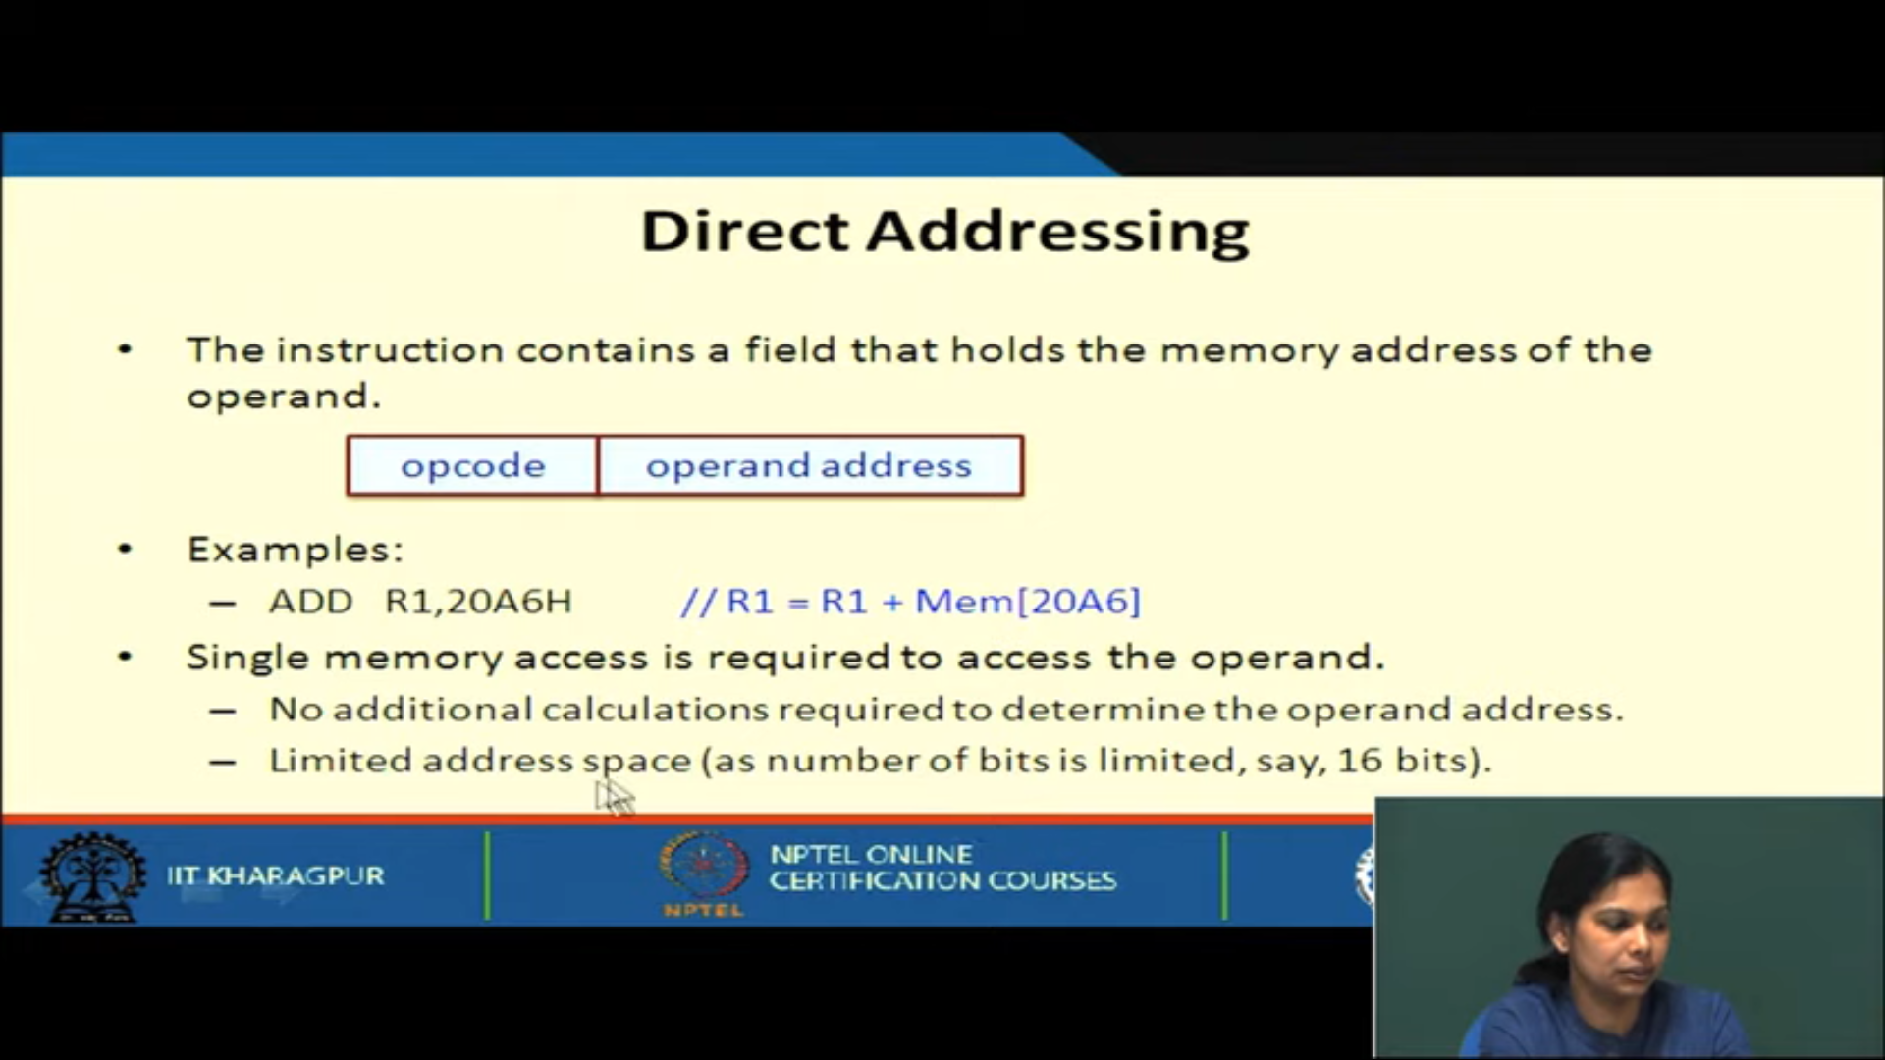

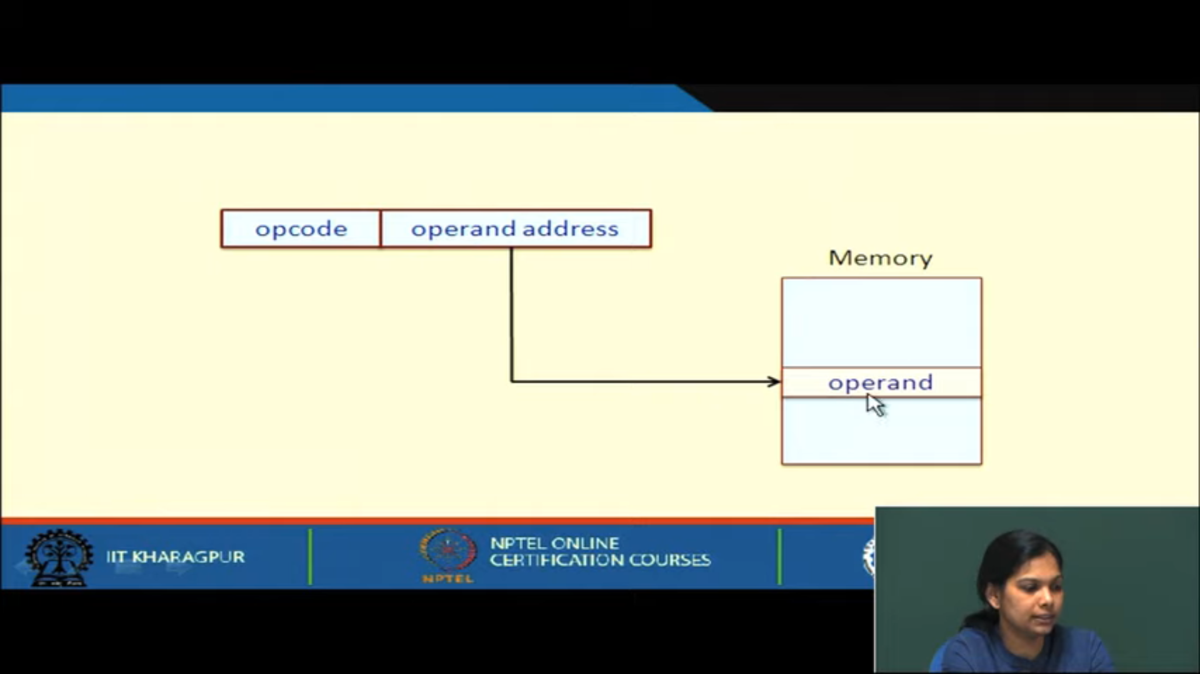

2 time memory access

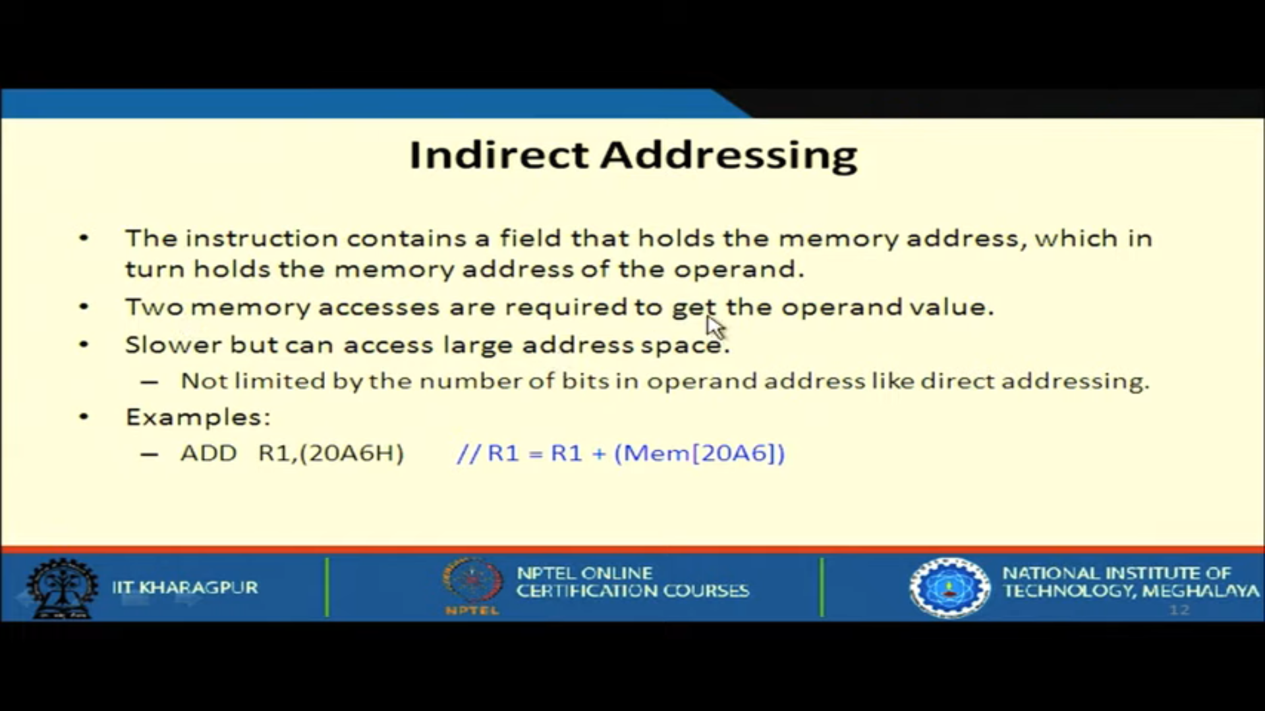

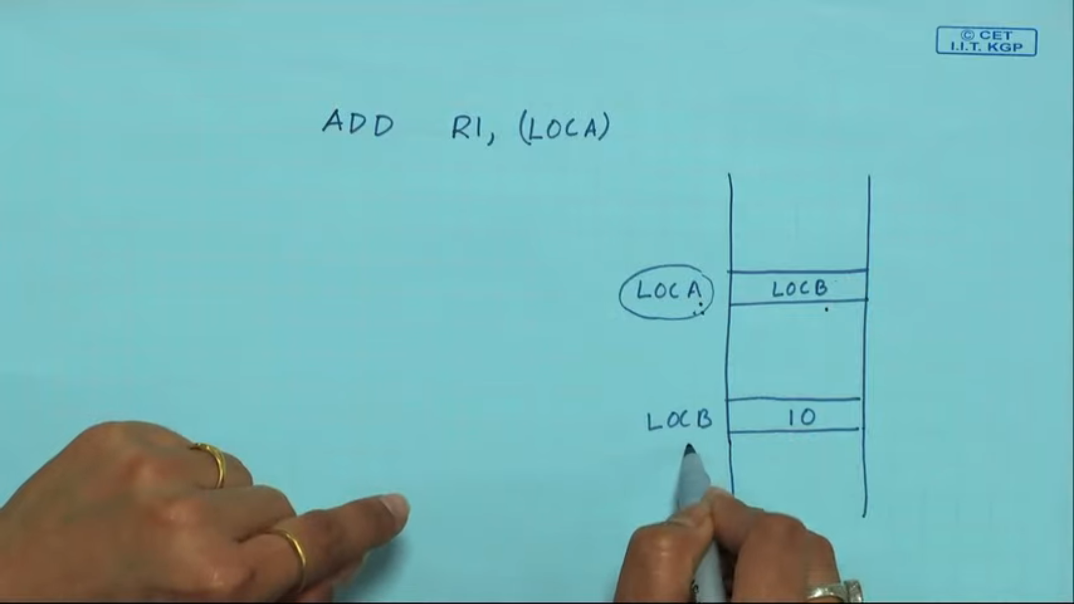

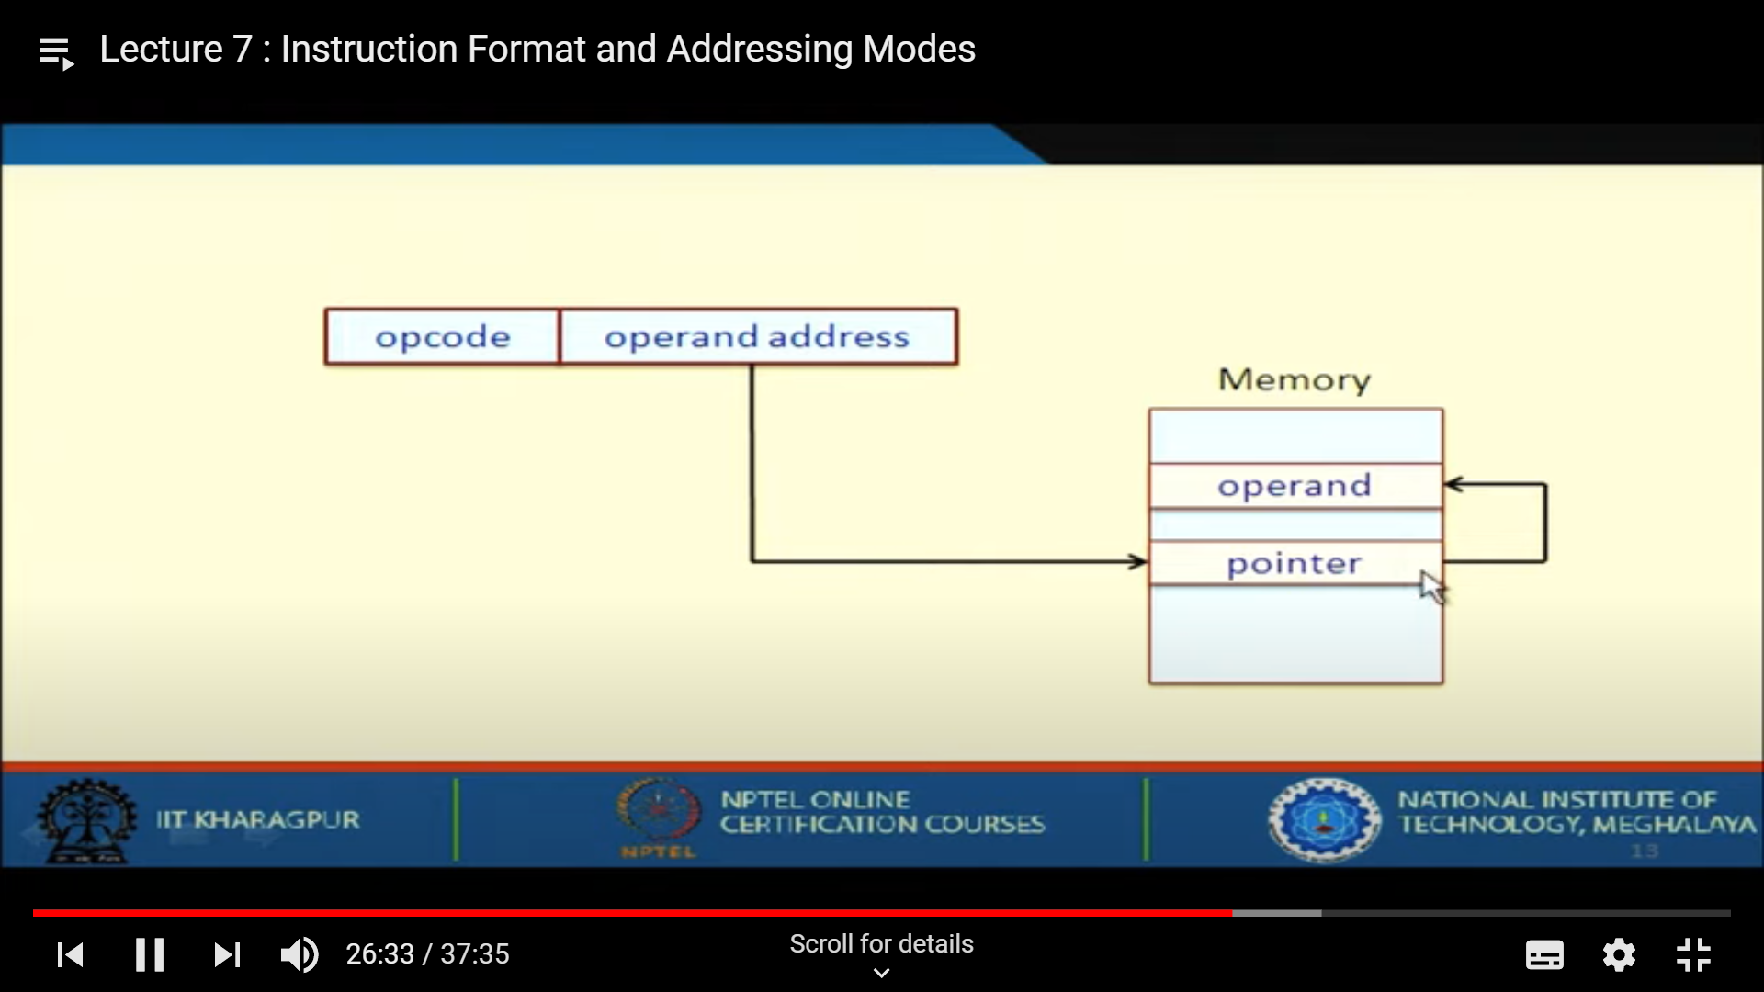

No memory accessing

